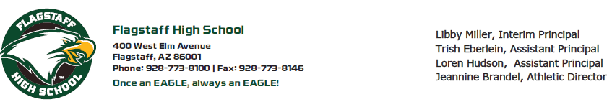

**Form B- Parent Permission**

Dear Parent or Guardian,

Your student has indicated an interest in Flagstaff High School Student Council for the 2025-2026 school year. As a result, they are now in the process of completing the application process.

Due to the responsibilities of holding office as well as the extra time, energy, and effort involved with being elected, you as the parents/guardians are being asked for your “show of support” for your student’s candidacy. Being elected or appointed to the Flagstaff High School Student Council will involve your child in an array of activities and functions, but will also expose your student to numerous opportunities that are not available to students not in Student Council.

Dedication, enthusiasm, creativity, and plain old hard work are just a few ways to describe what a student must commit themselves to in order to be a successful member of Student Council and thus reap the true learning advantages of the experience. Frequently, at the secondary level we find that actively involved students occasionally spread themselves too thin and suffer academically as a result. For this reason, your student must understand the consequences of their election to office. Being elected or appointed to Student Council will undoubtedly increase your student’s involvement in school activities. Candidates must also understand that as the advisor, I seek to make this council an active and productive group. The goal of the group is to represent the interests and concerns of the student body, as such students running for positions must maintain a high level of professionalism and leadership.

Student council will be part of your schedule and you are required to be enrolled in the class to participate in this governing board. If you run for an elected position, you will become a member of the Executive Board that is required to attend the 8:15 am meeting on the first Tuesday of every month. Part of your grade for Student Council is based on attending three school sponsored activities a month. This can include sporting events, concerts, plays, and competitions. Many of these events do require paid admission; which is your responsibility to cover that cost. Any regular season home game at FHS can be attended with the purchase of an activity pass for about $25 dollars, but this pass is not included in the class fees. This class also has a class fee of $25 dollars, which helps cover the cost of the Spirit Conference that we will attend in the Fall and the student council swag, which will be ordered over the summer.

Please take some time to discuss with your student the seriousness of a position on student council and all the aspects that accompany it. If you have any questions or concerns about any aspects of the FHS Student Council election process, please feel free to contact me at jaskew@fusd1.org

Thank you for your support and time. This parent permission form can be dropped off at the front office or if you are a current student given to Ms. Askew in Rm. 801.

Ms. Askew & Ms. Kerr

Student Council Advisors

Flagstaff High School

jaskew@fusd1.org & ekerr@fusd1.org

I ____________________________ give support/permission for _________________________ candidacy for

Parent/Guardian’s Name Candidate’s Name

an executive position in Student Council for the 2025-2026 school year.

Parent/Guardian’s Signature:________________________________ Date: _____________